<https://piazza.com/class_profile/get_resource/l1a9bvmlfoa462/l1l4136xplesw>

# Sprint 1 Plan

**GOAL**: The goal for this plan is to get a basic GUI that allows the user to design sequential neural networks. This will then be converted into tensor flow code, that the user can download as a .py file.

Must Have:

User Story 1: As a user of the website, I want a GUI for creating perceptron tensorflow networks, so that I can make them in an intuitive fashion.

Task 1: Graphical tool in front end to add Operator (+ button that expands)

Task 2: Functional tool to add Operator (+ button that expands)

Task 3: column/ expanding list of existing operators

Task 4: Graphical tool in front end to edit operator properties

Task 4.1: Gui component for single number generation, and pair of digits

Task 5: functional tool to edit operator properties

Task 6: Code generation button

Task 7: Code generation calls API

Task 8: Clear button

Task 9: Select multiple tensors

Task 10: Toggle snap to grid with button

User Story 2: As a user of the website, I want the GUI to allow for convolutional networks as well, so I can generate more types of networks.

Task 1: Backend function for creating fully connected sequential models

Task 2: Backend function for creating convolutional sequential models

User Story 3: As a user of the website, I want a GUI to also create pytorch networks, so that I can choose different implementations for the same network.

Task 1: colab file for testing pytorch network creation.

Task 2: python function that implements pytorch network

Could Have:

User Story 4: As a user of the website, I want it to tell me basic information about the network, such as number of parameters and number of layers, so I can have a better understanding of the network at a glance.

Task 1: Add small text on bottom

Task 2: single page pop up window tutorial. for now just always pop up. later worry about cookies

**TEAM ROLES**

Nico Ayala, Product Owner, Developer

**INITIAL TASK ASSIGNMENT**

Nico: Add operator function

Alex: Add operator component

Kat: google colab for pytorch

Mahesh: generate code function, passing front end network to backend network

Anish: Backend function for creating fully connected sequential models

**BURNUP CHART**

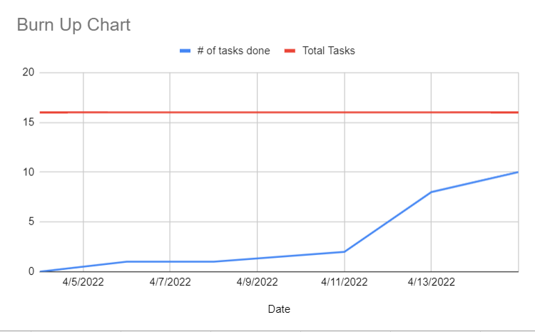

**SCRUM BOARD**

[**https://docs.google.com/spreadsheets/d/1JChBnZUPgPchSqaEMrG6jrwGF1h0Pw-hzuRS_t050S4/edit#gid=0**](https://docs.google.com/spreadsheets/d/1JChBnZUPgPchSqaEMrG6jrwGF1h0Pw-hzuRS_t050S4/edit#gid=0)

**SCRUM TIMES**

**mon-wed-fri afterclass**